1) Complete each sentence using an appropriate phrase from this list:
wound round | located within
connected across | applied to
mounted on | connected to
wired to | connected between

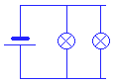 | 1. The lamps are the battery.
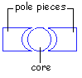 | 2. The core is the pole pieces.
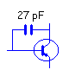 | 3. The 27pF capacitor is the collector and the base.
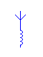 | 4. The antenna is the coil.
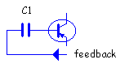 | 5. Feedback voltage is the base of the transistor through C1.
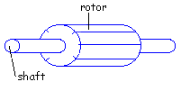 | 6. The rotor is the shaft.
 | 7. The coil is an iron core.
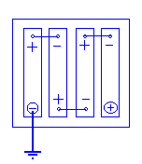 | 8. The negative pole of the battery is earth.
2) Using the diagram of the moving-coil meter, fill the spaces in this description of the meter.
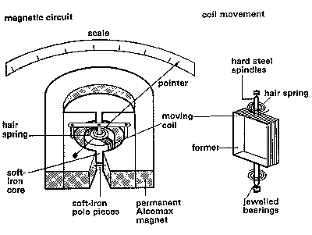

The essential components of a moving-coil meter are a (1) and a moving-coil. The magnet is (2) or semi-circular and is made of a material such as Alcomax. Each pole terminates in a curved (3) pole piece. The (4) which gives the instrument its name is composed of fine copper wire (5) a thin rectangular aluminium (6) . The former is mounted centrally on hard steel (7) and can rotate around a fixed cylindrical (8) . The core is (9) the pole pieces in such a way that an annular gap is formed between it and the pole pieces. A pointer is (10) the former and traverses a linear scale.
3) With the help of the diagram, fill in the gaps. Each gap represents one word. The description should answer these questions:
1 What is the diagram of?
2 What does it consist of in terms of blocks?
3 How are the blocks connected?
4 What is the function of each block?
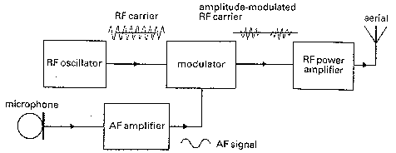

The figure shows the block diagram of an amplitude-modulated (AM) radio transmitter. It (1) of a radio frequency (RF) oscillator, a (2), an audio frequency (AF) amplifier, and an RF power amplifier. The RF (3) generates an RF (4) wave which is fed into the modulator.
The microphone converts sounds into audio frequency signals which are amplified by the AF (5). The modulator then uses the amplified AF (6) to modulate the RF carrier wave.
The power of the modulated carrier wave is increased by the RF (7) amplifier. The strong modulated output signals are fed to the (8) which enables them to be transmitted over long distances.

4) Study this diagram of a carbon resistor and consider how it is made.
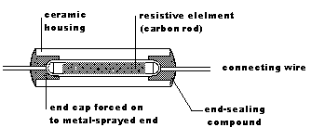

Now join the following groups of statements to make longer sentences. Use the words printed in italics above each group. You may omit words and make whatever changes you think are necessary in the word order and punctuation of the sentences.
1 which
A resistor is a component. A resistor is used to add resistance to a circuit.
2 which
Carbon resistors are made of compressed graphite. The graphite is formed into small tubes.
3 to
A ceramic coating is applied over the graphite. The ceramic coating insulates the graphite.
4 to
The ends of the graphite are sprayed with metal. This forms contacts.
5 which
End caps are forced on the metal-sprayed ends. The caps have connecting wires attached.
6 to
The ceramic is marked with colour bands. The bands indicate the value and tolerance.
7 which
Resistors are made in a range of preferred values. These values meet all the needs of circuit designers.
5) Each of these verbs has a related noun ending in -er or -or which refers to an instrument or component. Complete the column of nouns. You have met this nouns.
 | Verb | Noun
Example | record | recorder
1 | oscillate
2 | transmit
3 | transform
4 | charge
5 | rectify
6 | process
7 | amplify
8 | collect
9 | detect
10 | tune
6) Match each component or unit with its function in a battery charger.
For example :
.

Component/Unit | Function in a battery charger
1 transformer | a steps down the AC mains voltage
2 double-pole switch | b prevents the output from changing when the load varies
3 neon lamp | c keeps the diodes from overheating
4 fuse | d shows when the charger is on
5 rectifier | e removes the fluctuations in the DC output of the rectifier
6 aluminium heatsink | f protects the transformer
7 smoothing circuit | g converts the AC voltage to DC voltage
8 stabilizing circuit | h switches the charger on and off

2 |  | 3
4 |  | 5
6 |  | 7
8
7) Each word in column A ofen goes before one word from column B. For example, integrated circuit (1f). Find the other word pairs.
A | B
1 integrated | a sensor
2 circuit | b cell
3 alternating | c switch
4 primary | d supply
5 zener | e diode
6 remote | f circuit
7 reed | g current
8 surface | h bias
9 vibration | i control
10 reverse | j diagram
11 mains | k wave

