**Appendix 1: COURSE DESIGN**

**UNIT 1: Engineering- What is all about?**

**( Download the book ‘oxford english for electrical and mechanical engineering’by Eric H. Glendinning and Norman Glendinning through the site bookfi.org)**

1. **Reading:**
2. **Pre-reading activity:** Look at the following pictures and discuss about the different branches of engineering.

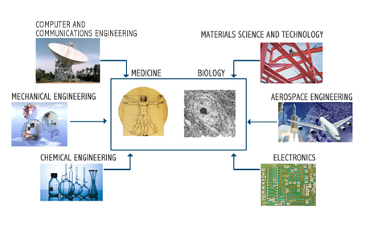

(http://www.google.com.au/search?hl=en&q=branches+of+biomedical+engineering&um)

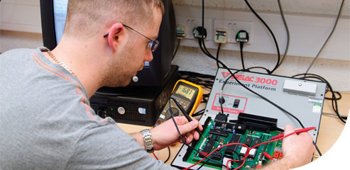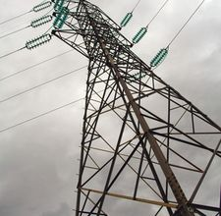

1. **Reading activities:**
2. *Read the following passage and find out how many branches of engineering are mentioned.*

Engineering is largely a practical activity. It is about putting ideas into action. Civil engineering is concerned with making bridges, roads, airports, etc. Mechanical engineering deals with the design and manufacture of tools and machines. Electrical engineering is about the generation and distribution of electricity and its many applications. Electronic engineering is concerned with developing components and equipment for communications, computing, and so on.

Mechanical engineering includes marine, automobile, aeronautical, heating and ventilating, and others. Electrical engineering includes electricity generating, electrical installation, lighting, etc. Mining and medical engineering belong partly to mechanical and partly to electrical.

1. Complete the blanks in this diagram using information from the text.

Engineering

Civil 1. ………….. Electrical 2. ………

3 ……… Automobile Aeronautical 4 ……. Electricity Electricity 6. ………

5. ……….. installation

7. …………. Medical

**3. a.** Read the following texts then match each one with the corresponding picture.

1. Transport: cars, trains, ships and planes are all products of mechanical engineering. Mechanical engineers are also involved in support services such as roads, rail track, harbours and bridges. **Picture …**

2. Food processing: Mechanical engineers design, develop and make the machines and the processing equipment for harvesting, preparing and preserving the foods and drinks that fill the supermarket. **Picture …**

3. Medical engineering: Body scanners, X-ray machines, life-support systems, and other high-tech equipment result from mechanical and electrical engineers combining with medical experts to convert ideas into life-saving and preserving products. **Picture …**

4. Building services: Electrical engineers provide all the services we need in our homes and places of work, including lighting, heating, ventilation, air-conditioning, refrigeration, and lifts. **Picture …**

5. Energy and power: Electrical engineers are concerned with the production and distribution of electricity to homes, offices, industry, hospitals, colleges and schools, and the installation and maintenance of the equipment involved in these processes. **Picture …**

**Picture 1 Picture 2**

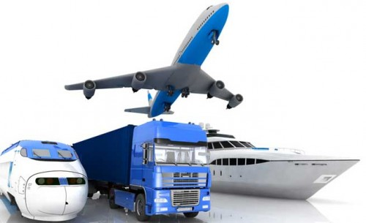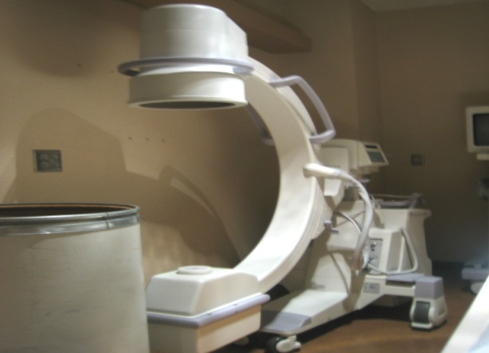

**Picture 3 Picture 4**

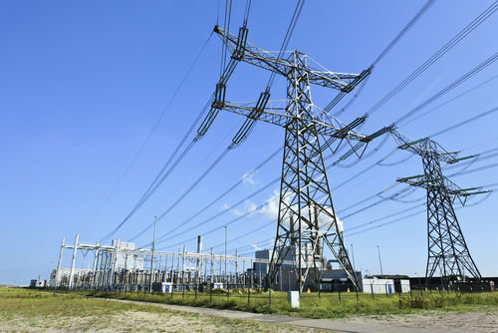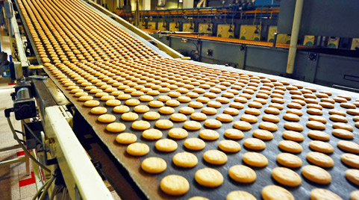

**Picture 5**

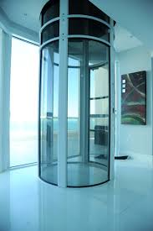

**b.** Match each text with the kind of engineers concerned with these areas.

Text 1

Text 2 Electrical

Text 3

Text 4 Mechanical

Text 5

1. **Post-reading activities:**
2. Summarize all what is done by filling the gaps.



**B. Word study:** Word stress Words are divided into syllables. For example:

Engine **‘**en.gine Two-syllable word

engineer en.gi**’**n.eer Three-syllable word

engineering en.gi**’**n.eer.ing Four-syllable word

* The stress is put on the third syllable from the end for words ending in **cal, ry, ty, phy…**

**‘**Che.mi.**cal**, **‘**che.mis.**try,** pho.**’**to.gra.**phy**, cu.ri.**’**o.si.**ty**.

**3/ 2 / 1**

* The stress is put on the second syllable from the end for words ending in **tion, ic, ics …**

**‘**Phy.**sics,** scien.**’**ti.**fic,** a.**’**to.**mic,** at.**’**trac.**tion.**

- Look at these words. Try to mark the stressed syllable. (Most students use electronic dictionaries)

1. machinery 2. mechanical 3. machine 4. install 5. installation 6. electricity 7. electrical 8. electronic 9. aeronautical 10. Ventilation

**C. Language study:** *deals with / is concerned with*

What is the link between column A and column B?

A B

Mechanical machines

Electrical electricity

Column A lists a branch of engineering or a type of engineer. Column B lists things they are concerned with. We can show the link between them in a number of ways:

1. Mechanical engineering ***deals with*** machines.

2. Mechanical engineers ***deal with*** machines.

3. Mechanical engineering ***is concerned with*** machines.

4. Mechanical engineers ***are concerned with*** machines.

5. Machines ***are the concern of*** mechanical engineers.

* Match each item in column A with an appropriate item from column B and join the two parts to form a sentence as the ones above.

|  |  |
| --- | --- |
| **A.** 1. marine  2. aeronautical  3. heating and ventilating  4. electricity generating  5. automobile  6. civil  7. electronic  8. electrical installation  9. medical | **B.** a. air-conditioning  b. roads and bridges  c. body scanners  d. cables and switch-gear  e. communication and  equipment  f. ships  g. planes  h. cars and trucks  i. power stations |

**D. Language in focus**

**Time Clauses**

**Time clauses** are used to show how actions are linked in time. The most common time links between two sentences are **when, until, before, as, once** and **after.** Comma is used after the time clause when it comes first in a sentence.

* When dealing with time clauses meaning scientific truth, the present simple tense is usually used in both clauses.

1. **After** it feeds them into microchip, they are interpreted and verified.

Pr. S Pr. S in passive

1. **Once** they are interpreted and verified, your instructions are carried out.
2. **When** a photodiode picks up rays from the remote control, it feeds them into a decoding microchip.
3. **As** the coil approaches the object, the audible note becomes louder and louder.

* When using two successive actions referring to the present time, the present simple tense is usually used in the adverb clause of time and the future simple tense is used in the main clause.

1. **After** she graduates, she will get a job.
2. I will leave **before** he comes.
3. **When** I see him tomorrow, I will ask him.
4. **Once** it stops raining, we will leave.

* When using two successive actions referring to the past time, the action that happened first should be in the past perfect tense and the other one in the past simple tense.

1. **After** she had graduated, she got a job.
2. I had left **before** he came.
3. **When** I got there, he had already left.

**PRACTICE**

**A. Complete the following. Pay attention to verb tenses.**

1.Last night I went to bed after I _________ my homework.

2. Tonight I will go to bed after I ______________ my homework.

3. Be sure to reread your composition for errors before you __________ it in to the teacher tomorrow.

4. We will have a big party when _____________.

**B. Complete the following sentences. Punctuate carefully. Pay attention to verb tense usage.**

1. I’ll help you with your homework as soon as I .............................................

2. Just before I ................................................................

3. I had already ................................. when ......................

4. I will be here until I ..................................................